TARIF MATELAS ORDINAIRES(MACACI)

MATELAS 1PLACE MATELAS 2PLACES

Longueur | Largueur | Epaisseur | prix |  | Longueur |  | Largeur |  | Epaisseur |  |  |  |  | Prix
190 | 90 | 13 | 78.500F |  | 190 |  | 140 |  | 13 |  |  |  |  | 125.000F
190 | 90 | 15 | 92.000F |  | 190 |  | 140 |  | 15 |  |  |  |  | 147.500F
190 | 90 | 18 | 124.000F |  | 190 |  | 140 |  | 18 |  |  |  |  | 198.500F
190 | 90 | 20 | 147.500F |  | 190 |  | 140 |  | 20 |  |  |  |  | 233.500F
200 | 90 | 13 | 82.500F |  | 200 |  |  | 140 |  |  | 13 |  |  | 132.500F
200 | 90 | 15 | 97.000F |  | 200 |  |  | 140 |  |  | 15 |  |  | 154.500F
200 | 90 | 18 | 130.500F |  | 200 |  |  | 140 |  |  | 18 |  |  | 209.000F
200 | 90 | 20 | 154.000F |  | 200 |  |  | 140 |  |  | 20 |  |  | 245.000F
Traversin | 90 | 0 | 119.000F |  | Traversin |  |  | 140 |  |  | 0 |  |  | 16.000F
Sommier190 | 90 | 0 | 33.680F |  | Sommier |  |  | 140 |  |  | 0 |  |  | 147.430F
Canapé lit | 90 | 0 | 119.775F |  | Canapé lit |  |  | 140 |  |  | 0 |  |  | 183.655F
MATELAS 2PLACES ET DEMI (2.5) |  |  |  |  | MATELAS 3PLACES
190 | 160 | 13 | 143.5000F |  | 190 | 180 |  |  |  |  | 13 |  |  | 139.500F
190 | 160 | 15 | 167.500F |  | 190 | 180 |  |  |  |  | 15 |  |  | 189.000F
190 | 160 | 18 | 226.000F |  | 190 | 180 |  |  |  |  | 18 |  |  | 255.500F
190 | 160 | 20 | 266.500F |  | 190 | 180 |  |  |  |  | 20 |  |  | 299.500f
200 | 160 | 13 | 150.500F |  | 200 | 180 |  |  |  |  | 13 |  |  | 169.000F
200 | 160 | 15 | 176.000F |  | 200 | 180 |  |  |  |  | 15 |  |  | 198.500F
200 | 160 | 18 | 238.500F |  | 200 | 180 |  |  |  |  | 18 |  |  | 267.500F
200 | 160 | 20 | 280.000F |  | 200 | 180 |  |  |  |  | 20 |  |  | 314.500F
Traversin | 160 | 0 | 19.000F |  | Traversin | 180 |  |  |  |  | 0 |  |  | 22.0000F
Sommier190 | 160 | 0 | 170.870F |  | Sommier190 | 180 |  |  |  |  | 0 |  |  | 182.385F
Canapé lit | 160 | 0 | 217.100F |  | Canapé lit | 180 |  |  |  |  | 0 |  |  | 234.050F
oreiller 65 | 45 | 10 | 16.500F | unité
Berceau120 | 60 | 13 | 35.000F | ballons  gonflables  perso |  | 200 ballons |  |  |  | 30mill
Berceau130 | 70 | 13 | 40.000F
Sommier200 | 200 | 0 | 203.255F

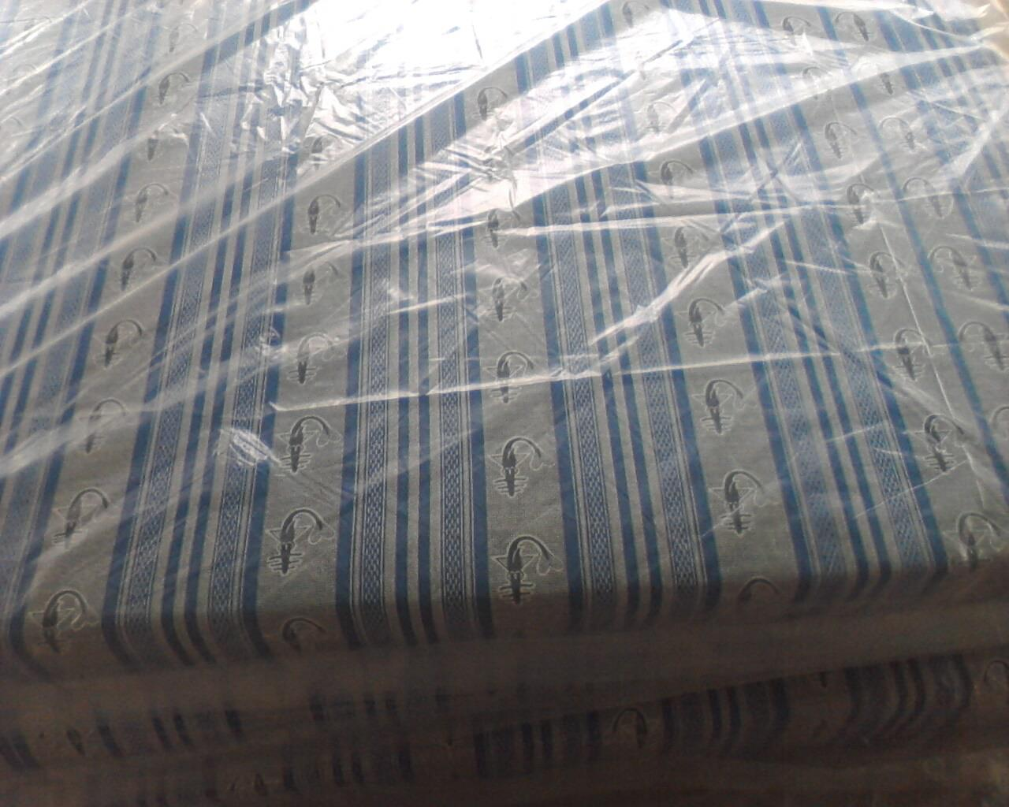
CONTACT: 03.74.89.00 - 07.91.12.66 MR COULIBALY
EMAIL: macaci225@yahoo.fr oreillers ,10cm

