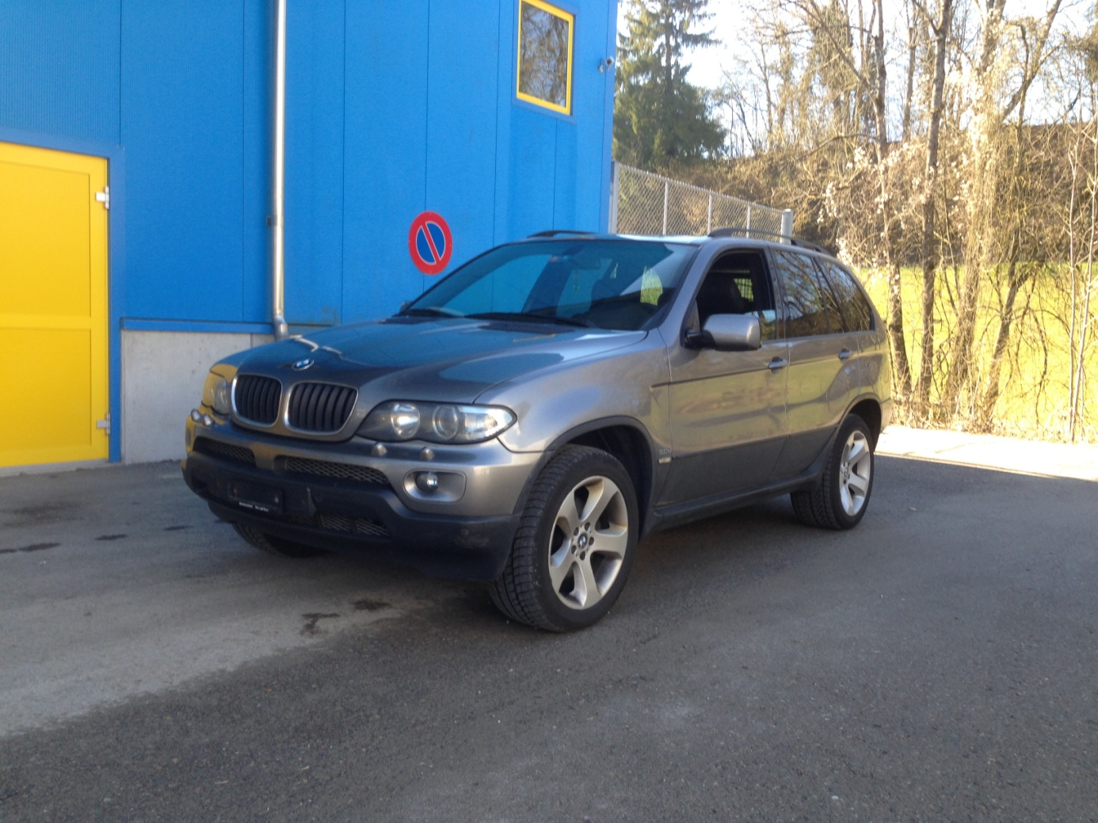
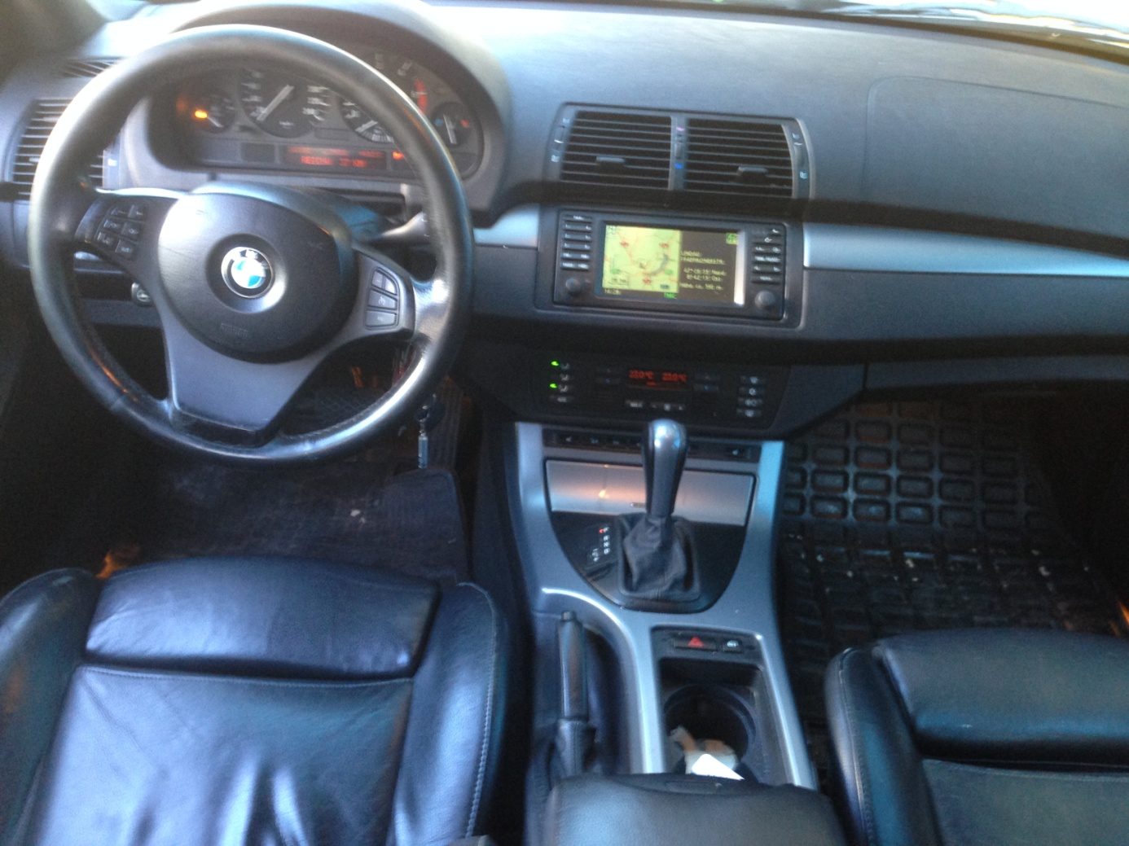

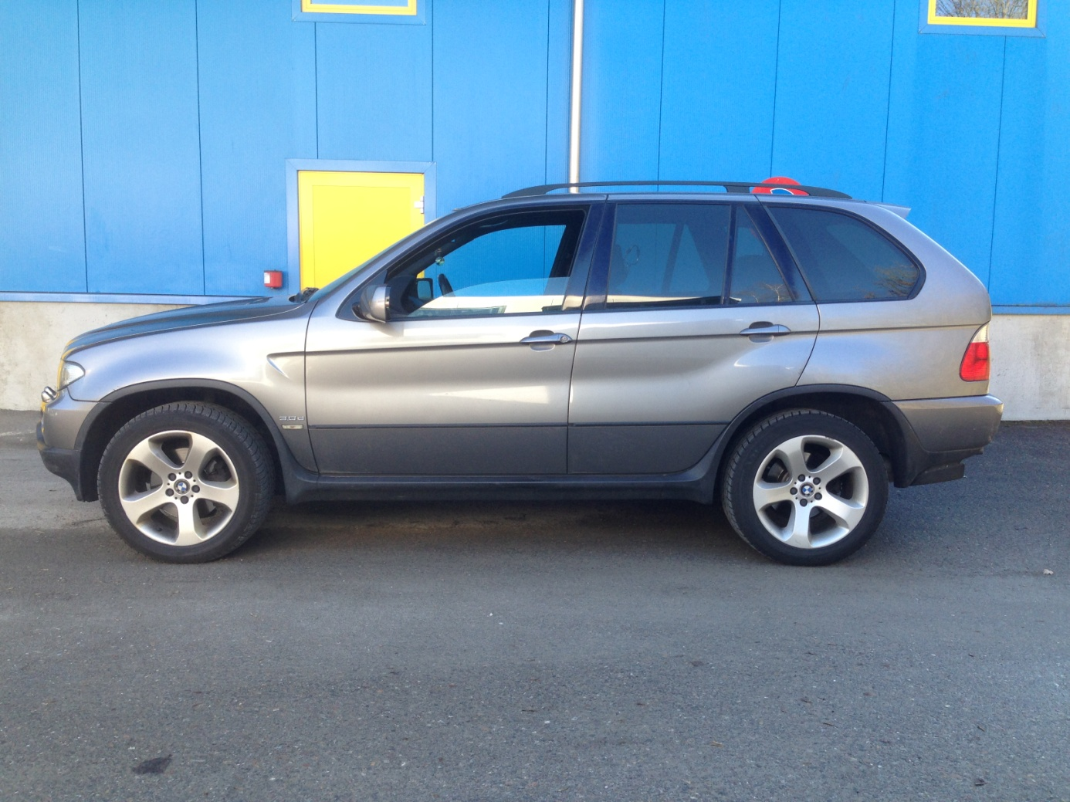
BMW X5 FACE LIFT / FCFA 13.900.000 A DEBATTRE
- DIESEL
- ANNEE 2004
- INT. CUIR
- CLIM
- AUTOMATIQUE
- CD-PLAYER, RADIO
- NAVI
- EXPERTISEE

