- International Services
- Internet connectivity
- MPLS
- GLOBAL VOIP
- Mobile Satellite Services
- Domestic Services
- Private Networks
- Cellular backhaul
- broadcast
- Turnkey projects
- 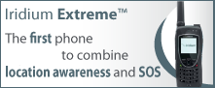
- 
- Markets
- isp's & telcos
- MOBILE operators
- broadcasters
- CORPORATIONS & NGO'S
- ENERGY & UTILITIES
- banking & finance
About gilat satcom
In today’s fast-paced telecommunications era, there are still billions ofpeople living in remote areas beyond the reach of traditional
Read More


